NASA ISS FIT Admin Tool – User Guide
12/09/2016

Table of Contents
1.0 Overview 3
1.1 View User Data 3
1.2 View User Details 4
1.3 Edit User Data 5
1.4 Delete User Data 5
1.5 Search User 5
1.6 Create New User 5
1.7 View Food Data 7
1.8 View Food Details 7
1.9 Edit Food Data 8
1.10 Delete Food Data 9
1.11 Search Food 9
1.12 Create New Food 9
1.13 Generate Food Data Report for Users 11
1.14 Import User Data by CSV file 11
1.15 Import Food Data by CSV file 12
1.16 View Instructions 12

Overview
The NASA ISS FIT Admin tool is designed to be intuitive and user-friendly. By following the instructions in this user guide you will be able to understand exactly how to use admin tool. Below are details on the functionality available to Users.

View User Data
In a browser, load the admin tool, and you’ll see the dashboard. There are several tabs available – “User Data”, “Food Data”, “Reports”, “Import” and “Instructions”.

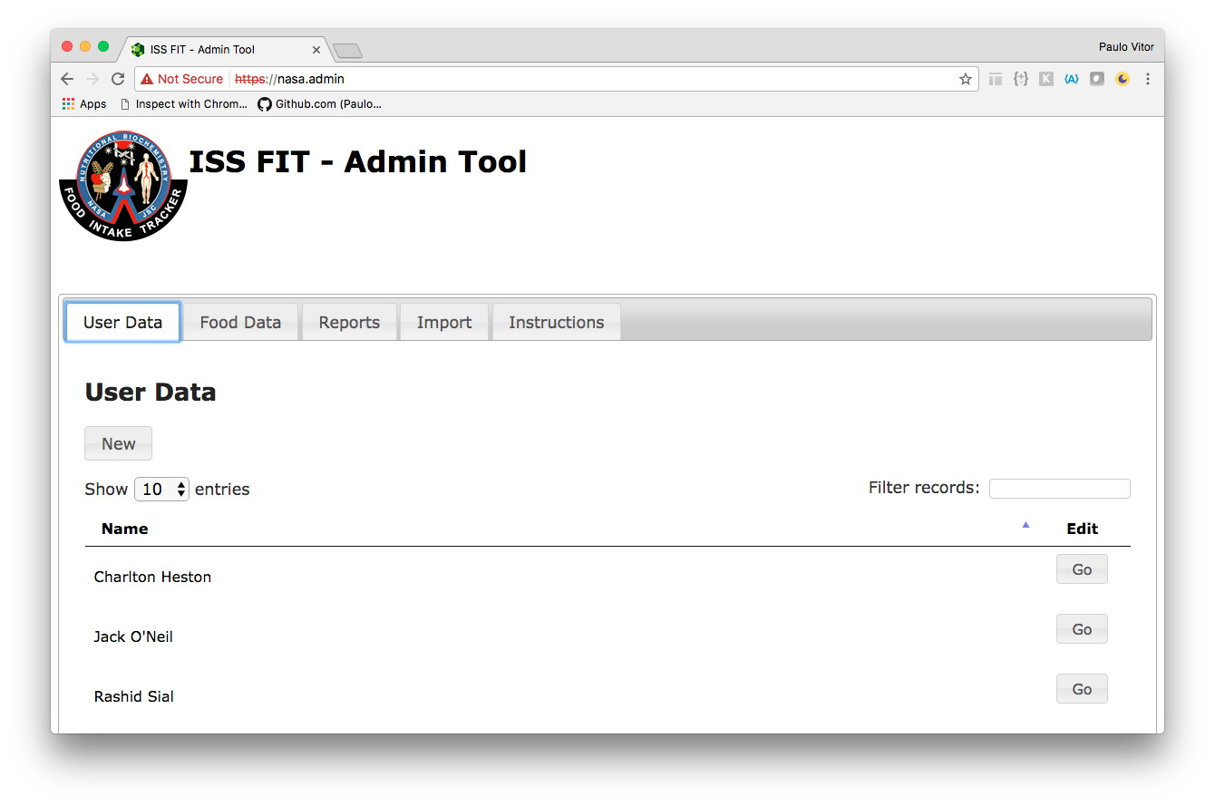

By default the “User Data” tab is chosen. It will display 10 records per page in the table. On the bottom left of the page, it will display the range of entries on the current page and total number of entries.

The user can update the page by choosing the number of entries per page from the dropdown:

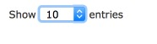
Standard pagination is available too: 

View User Details
On each row of the users table, there is a “Go” button that can be clicked to view user details: 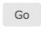

The user details will be displayed in the following manner:

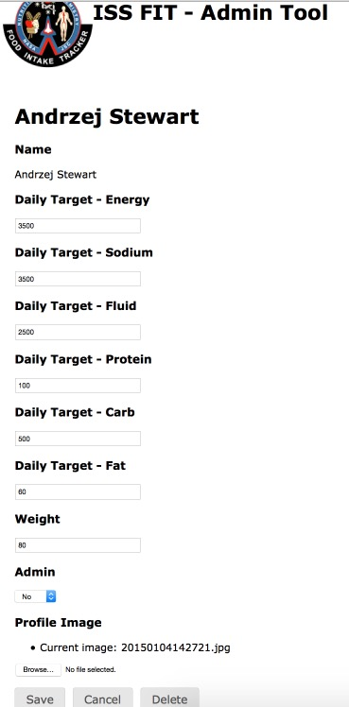

Edit User Data
User data can be edited on the user details page as shown in the screenshot example in section 1.2. Just fill in the proper value of each field and press the “Save” button.

Also, you can add or change the profile image by uploading an image by pressing the “Browse…” button.

If you press the “Cancel” button, there will be no changes saved for the chosen user. The user will be redirected to “User Data” page.

Delete User Data
Pressing the “Delete” button can delete the user data on the user details page as shown in the screenshot example in section 1.2.

Be aware that this action will not prompt a confirmation dialog asking whether to delete.

Pressing the “Delete” button will delete the chosen user data immediately. After that a success message will be shown in a modal:
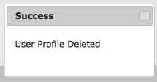

Search User
There is a search box on the top right of the page used for searching users. It provides a dynamic way to filter the table. Users can enter characters in the box and then the results in the table will be updated based on the matched characters.

For example, user enters “k” in the box, then all names which contain “k” (case insensitive) will be filtered and displayed.

The screen example looks like this:
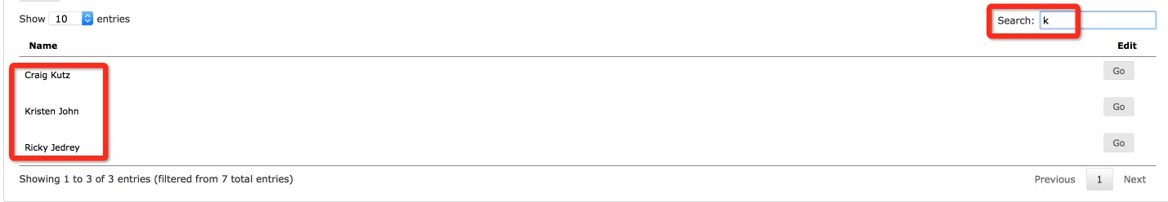

Create New User
There is a “New” button on the “User Data” page. Clicking it will lead to a “New User” creation page:

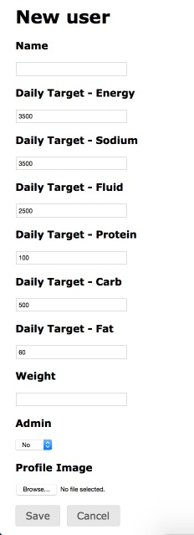

There are some default values on the page. The user can enter new values for each field. Optionally, the user can choose an image to upload as a profile image. Pressing “Save” will create the new user. Pressing “Cancel” will terminate the creation process and go back to the previous page. If a new user is created successfully, the following modal will be displayed:
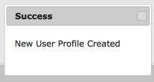

View Food Data
Clicking the “Food Data” tab to view food data list. The screen example is like the following:
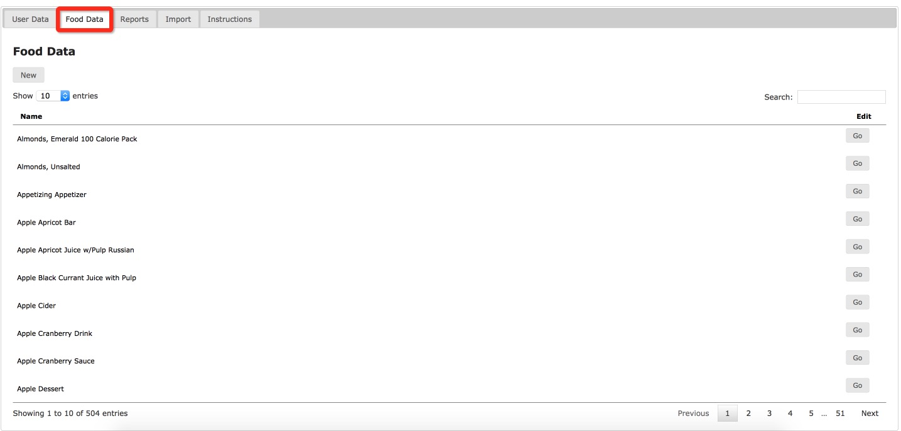

It will display 10 records per page in the table. On the bottom left of the page, it will display the range of entries on the current page and total number of entries.

The user can update the page by choosing the number of entries per page from the dropdown:

Standard pagination is available too:

View Food Details

On each row of the food table, there is a “Go” button that can be clicked to view food details:

The food details will be displayed like:

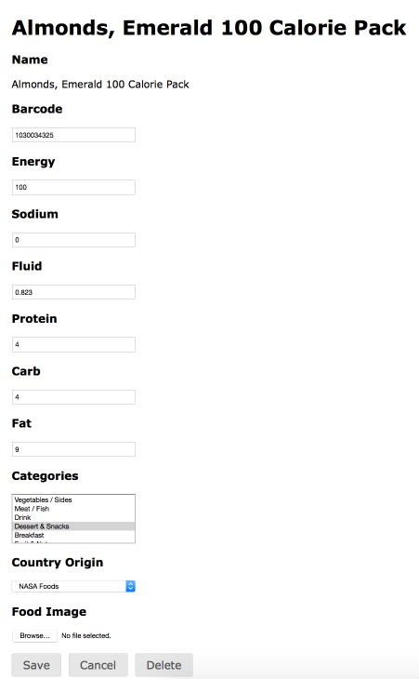

Edit Food Data

Food data can be edited on the food details page like shown in the screen example in section 1.8. Just fill in proper value of each field and press the “Save” button.

Also, it is allowed to add or change the food image by uploading an image by pressing “Browse…” button.

If pressing “Cancel” button, there will be no changes saved for the chosen food. The user will be redirected to food data page.

Delete Food Data

Pressing the “Delete” button can delete the food data on the user details page like shown in the screen example in section 1.8.

Be aware that this action will not prompt a confirmation dialog asking whether to delete. Pressing the “Delete” button will delete the chosen food data immediately. After that a success message will be shown in a modal:
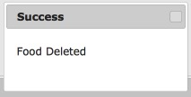

Search Food
There is a search box on the top right of the page used for searching food data. It provides a dynamic way to filter the table. User can enter characters in the box then the results in the table will be updated based on matched characters.

For example, user enters “apple cr” in the box, then all names which match the input (case insensitive) will be filtered and displayed.

Screenshot:
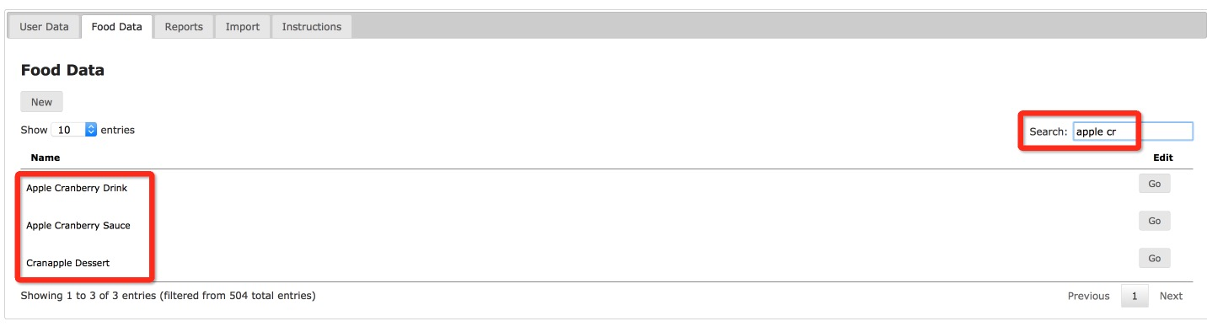

Create New Food
There is a “New” button on the “Food Data” tab. Clicking it will lead to a “New food” creation page:
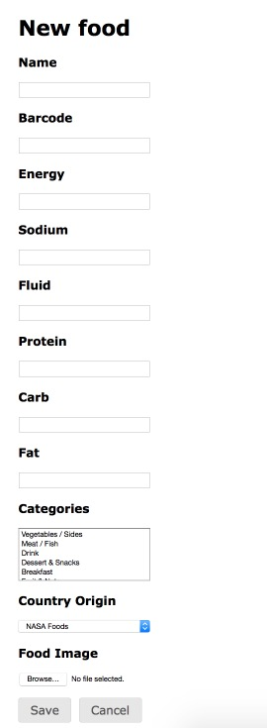

The user can enter valid values for each field. Optionally, the user can choose an image to upload as a food image. If all values are valid, pressing “Save” will create the new food. Pressing “Cancel” will terminate the creation process and go back to the previous page. Here’s what the success prompt looks like:
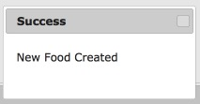

Generate Food Data Report for Users
In the “Reports” tab, it is possible to generate a report for user data.

There are two options: “User Food Data Report” and “All Users Food Data Report”. See the screen example:
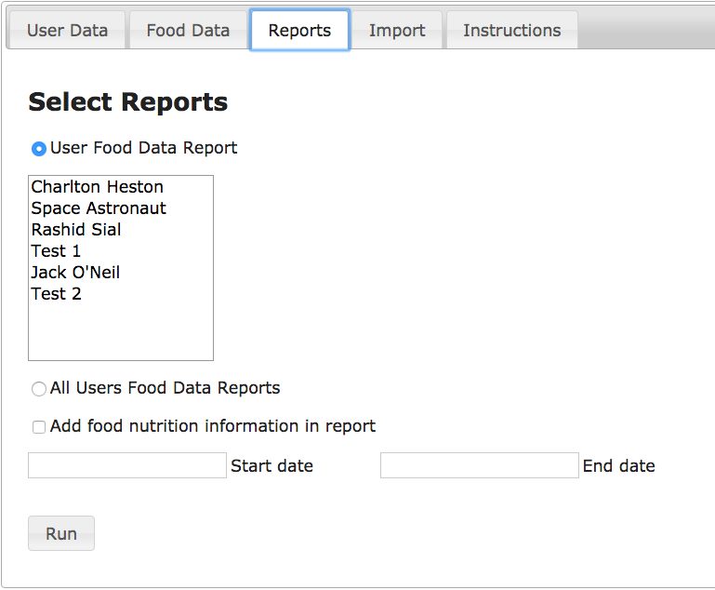

For the first option, there are multiple users that can be chosen. Clicking “Run” will generate a report for the chosen users.

For the second option, it will generate a food data report for all users.

You can use the checkbox to add Food Nutrition information in the report.

Start and end date can be selected as well.

The generated report can be saved locally.

Import User Data by CSV file
In the “Import” tab, it is possible to import user data by uploading a CSV file.

Prepare a CSV file with proper user data, click the “Browse…” button to select it, then click the “Import” button to import the user data.

Optionally, a zip file containing users profile images can be uploaded. The name of the file should match the value found inside the CSV file.
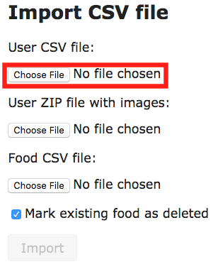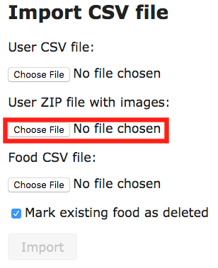

Import Food Data by CSV file
In the “Import” tab, it is possible to import food data by uploading a CSV file.

The format of the CSV file must follow the instructions shown in the “Instructions” tab.

Prepare a CSV file with proper user data, click the “Browse…” button to select it, and then click the “Import” button to import the data.

Optionally you can mark the checkbox to make all existing data in the iPad apps as deleted.

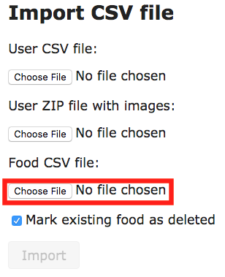

View Instructions
In the “Instructions” tab, it displays instructions on how to import/update/delete food data by uploading a CSV file.

